|  |  |
| --- | --- |
| Roll. No.: A016 | Name: Varun Khadayate |
| Sem/Year: VII/4 | Batch: 1 |
| Date of Experiment: 13/08/2022 | Date of Submission: 13/08/2022 |
| Grade -- |  |

Study of J2Me with Hello world

This is the simple hello world application. In this example we are creating a form name "Hello World" and creating a string message "Hello World!!!!!!!" as below:

**Form form = new Form("Hello World");**

**String msg = "Hello World!!!!!!!";**

In this application, To display the message we are using append method with the form as below:

**form.append(msg);**

**The Application is as follows:**

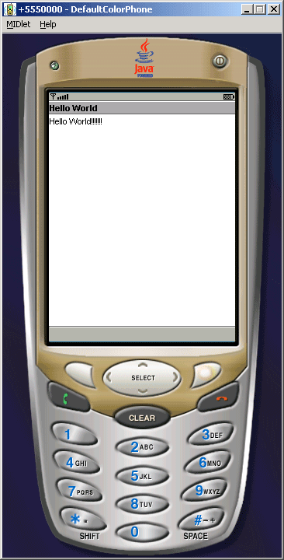

**HelloWorld.java**

|  |
| --- |
| **import**javax.microedition.lcdui.*; **import**javax.microedition.midlet.*;  **public class**HelloWorld **extends**MIDlet{   **private**Form form;   **private**Display display;    **public**HelloWorld(){   **super**();   }    **public void**startApp(){   form = **new**Form("Hello World");   String msg = "Hello World!!!!!!!";   form.append(msg);   display = Display.getDisplay(**this**);   display.setCurrent(form);   }    **public void**pauseApp(){}      **public void**destroyApp(**boolean**unconditional){   notifyDestroyed();   } } |